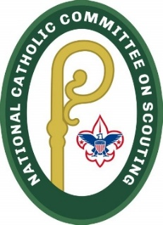

Diocese of Paterson Catholic Committee on Scouting
Scouting Retreat 2025

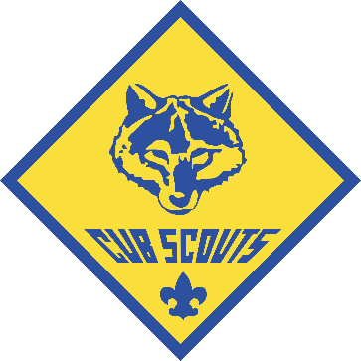


Date: September 28, 2025
Time: 12:00 PM – 5:00 PM
Location: St. Francis de Sales Church
614 McAfee Glenwood Road Vernon, NJ 07462
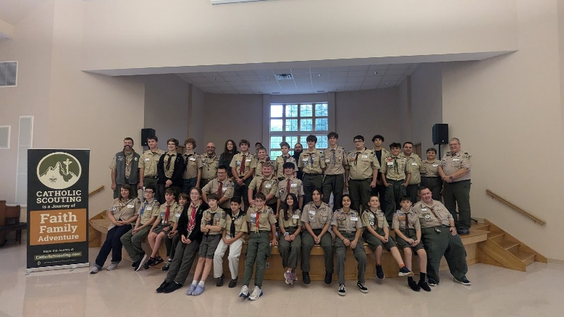
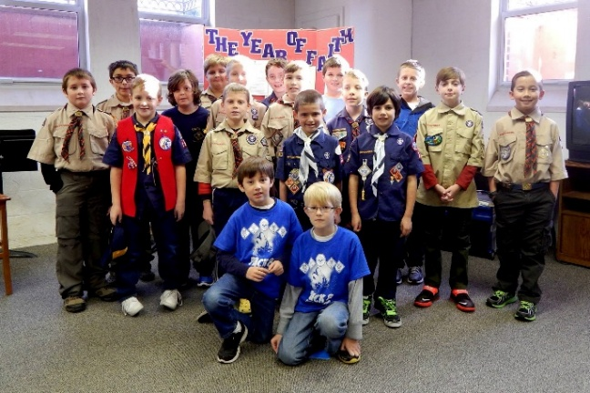

Cost: $25/Scout
Sign up link: https://forms.gle/vSkRsJNCzRRkeUnW9

For more information, contact Greg Bubniak at dopccschairman@gmail.com
Come join your fellow Scouts from throughout the Diocese of Paterson! We will begin with Mass at Noon and then have some fun activities that will help us connect the best of Scouting and out Catholic faith! Lunch and an event patch are included.

