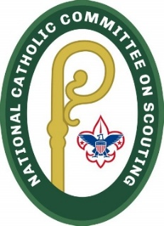

Diocese of Paterson Catholic Committee on Scouting America
Scouting Retreat 2026

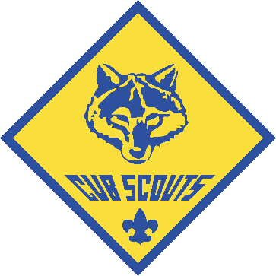
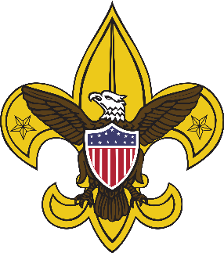

Date: October 24-25, 2026
Time: 4:00 PM (Saturday) – 11:00 AM
Location: St. Francis de Sales Church
614 McAfee Glenwood Road Vernon, NJ 07462

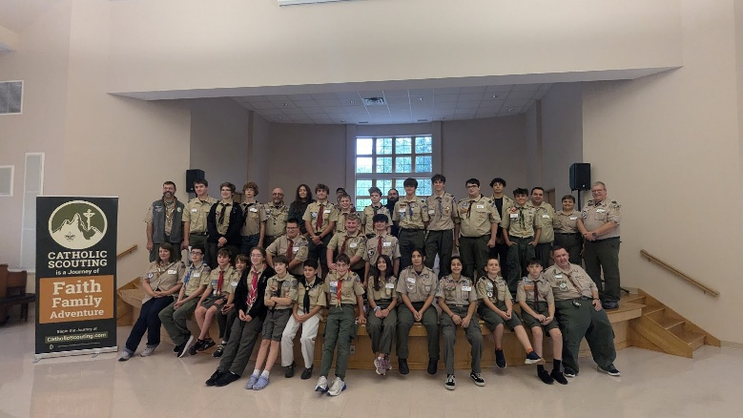
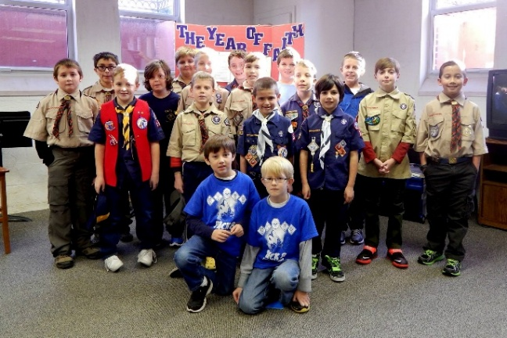
Cost: $35/Scout
Come join your fellow Scouts from throughout the Diocese of Paterson! We will begin with Mass at Noon and then have some fun activities that will help us connect the best of Scouting and our Catholic faith! Lunch and an event patch are included. Catholic Scouters and older Scouts are welcome to join us conductinbg this retreat, please let us know your interest!
Retreat signup using this link: https://forms.gle/VujJ6VnHnf816tor5
For more information, contact Greg Bubniak at dopccschairman@gmail.com

